# LIDL Compiler user and developer manual

## Configuring the runtime environment

In this manual, we use the Java environment information as shown in the following figure.

Specifically, the Java version is 17.0.5 and the path is the default installation path of Java.

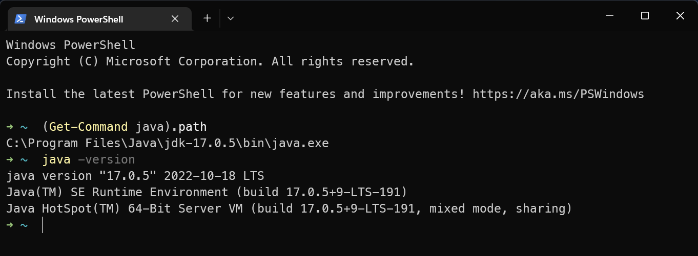

## Calling the compiler from the terminal

The compiler executable file is Lidl2Lustre.jar and the path is

Zenodo: /LIDL MEC Toolkit/software/Compiler/Lidl2Lustre.jar

GitHub: /LIDL-MEC-Toolkit/software/Compiler/Lidl2Lustre.jar

The compiler relies on the lib folder in the same directory and the lang.lidl file in it when executing

Invoke the compiler in the terminal and present the compiler help information with the -h parameter.

Terminal command:

java -jar Lidl2Lustre.jar -h

Execution results:

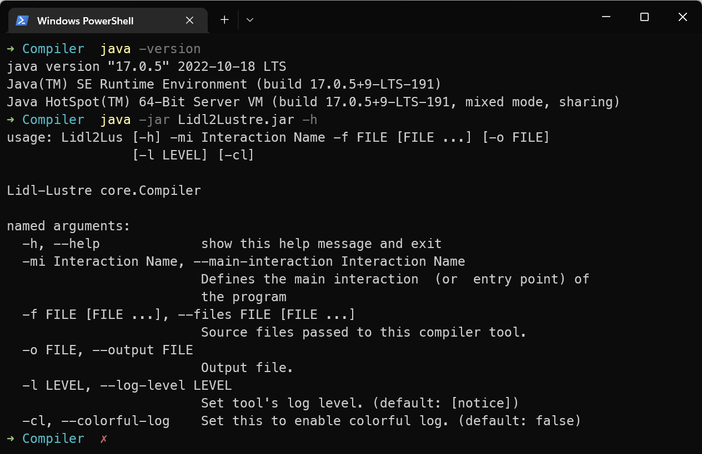

## Test cases

The path to the directory where the test cases are located in:

Zenodo: /LIDL MEC Toolkit/software/Compiler/cases

GitHub: /LIDL-MEC-Toolkit/software/Compiler/cases

The file directory is shown in the following figure.

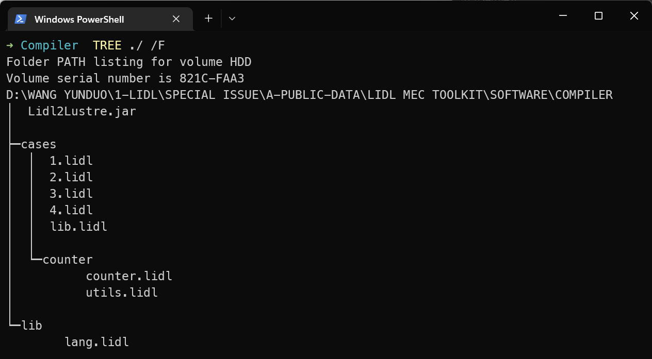

Case 1: 1.lidl

Case 2: 2.lidl

Case 3: 3.lidl

Case 4: 4.lidl

Case counter: counter/counter.lidl, counter/utils.lidl

## Case 1

The command to compile Case 1 is:

java -jar Lidl2Lustre.jar -f ./cases/1.lidl -mi "Case 1" -o ./cases/1.lus

Parameter meaning:

-f specifies the input LIDL code file

-mi sets the name of the Main Interaction used at compile time

-o specifies the path to the output Lustre code file

The result of the compilation is as follows.

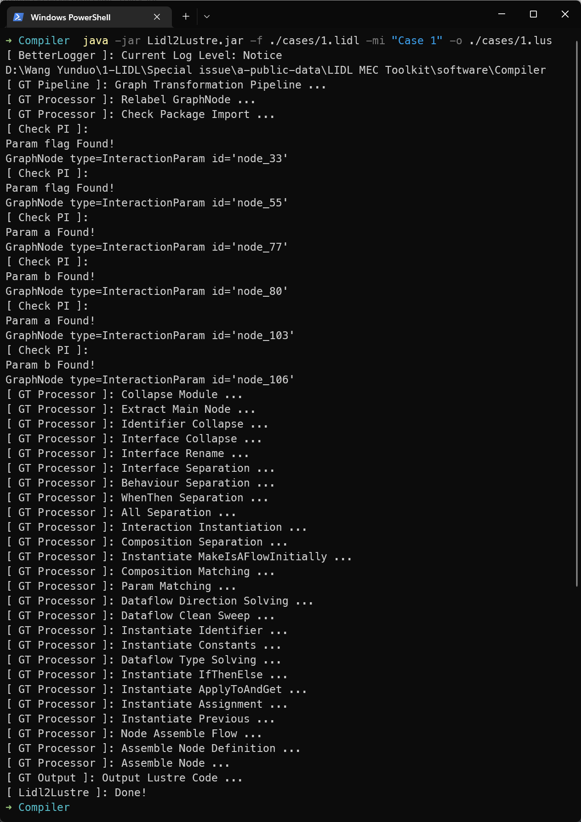

## Case 2

The command to compile Case 2 is

java -jar Lidl2Lustre.jar -f ./cases/2.lidl -mi "Case 2" -o ./cases/2.lus

The result of the compilation is as follows.

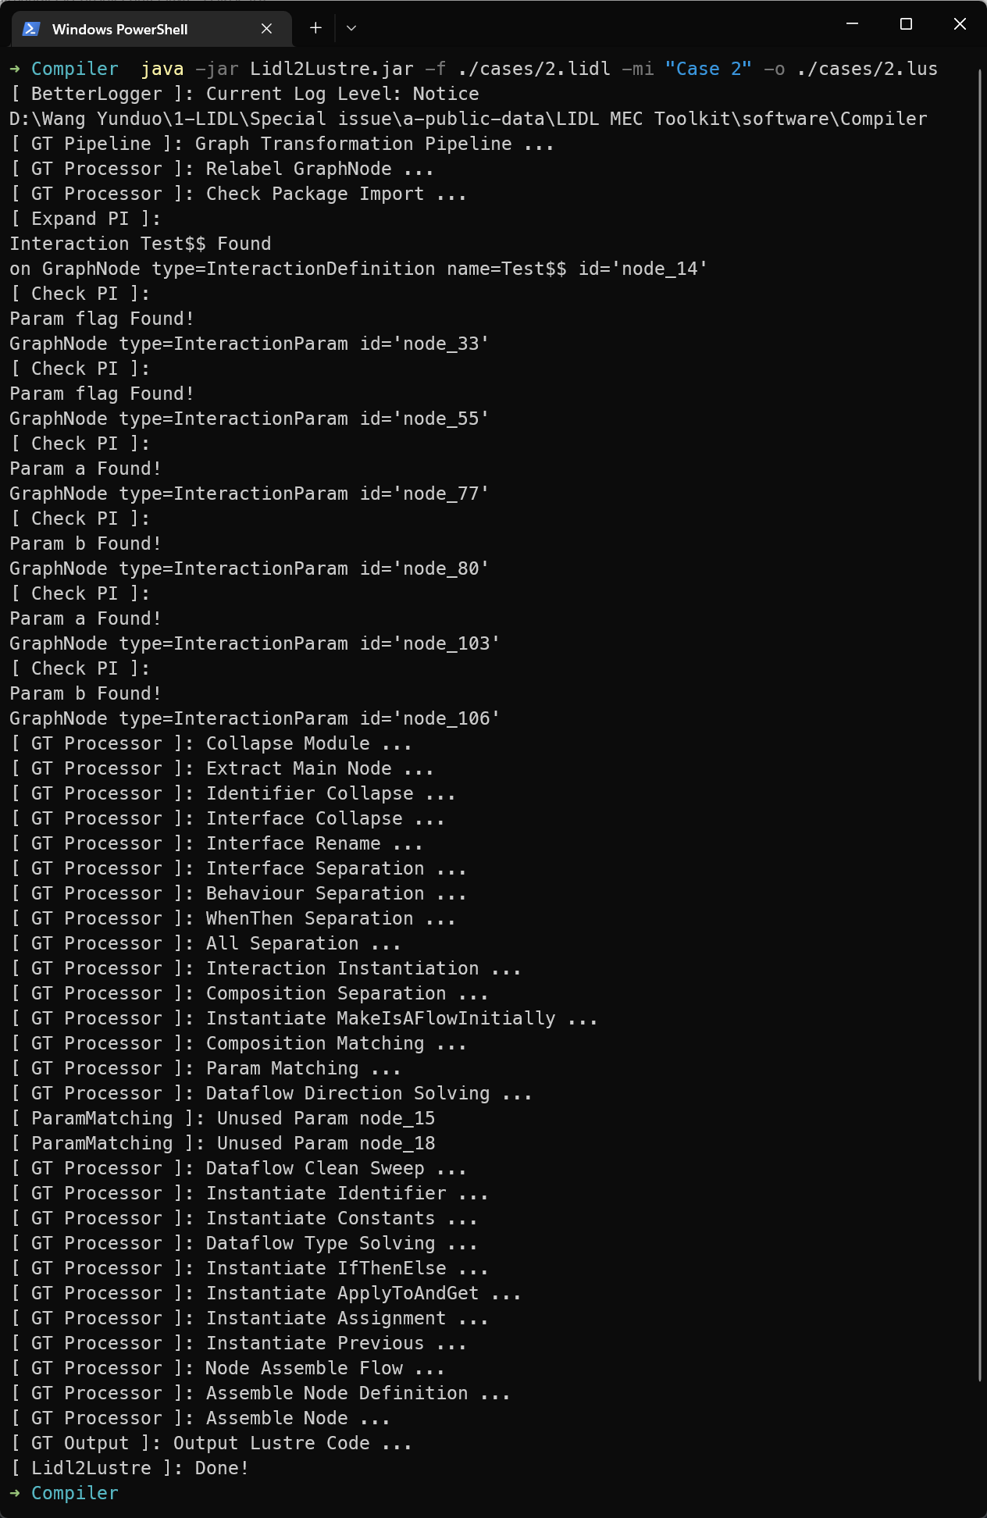

## Case 3

The command to compile Case 3 is

java -jar Lidl2Lustre.jar -f ./cases/3.lidl -mi "Case 3 () ()" -o ./cases/3.lus

The result of the compilation is as follows.

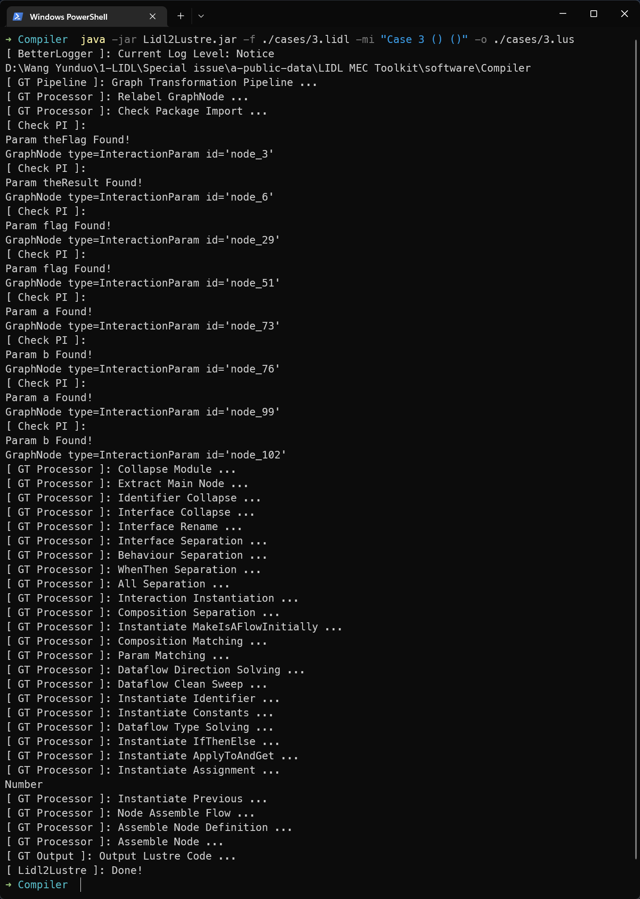

## Case 4

The command to compile Case 4 is

java -jar Lidl2Lustre.jar -f ./cases/4.lidl -mi "Case 4 () ()" -o ./cases/4.lus

The result of the compilation is as follows.

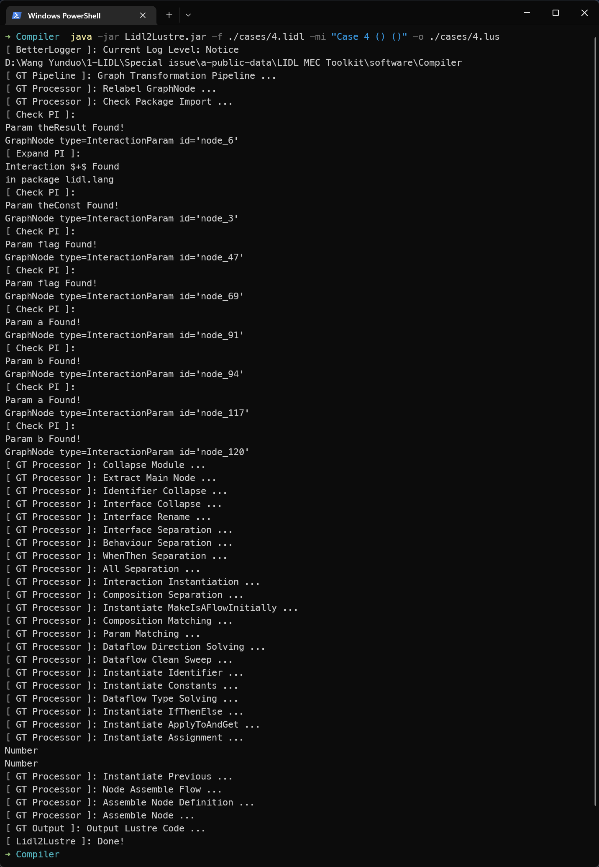

## Case counter

The compile command is

java -jar Lidl2Lustre.jar -f ./cases/counter/counter.lidl ./cases/counter/utils.lidl -mi "MainUI" -o ./cases/counter/counter.lus

The result of the compilation is as follows.

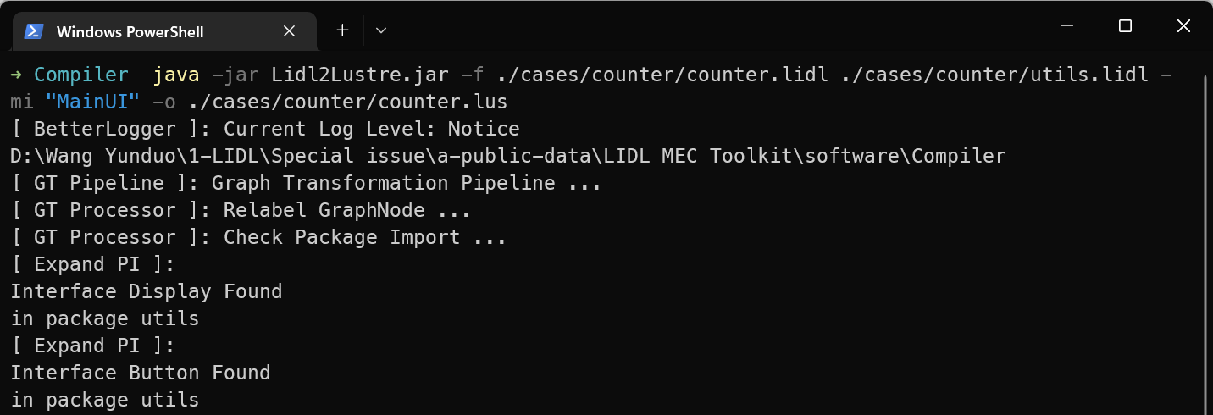

……

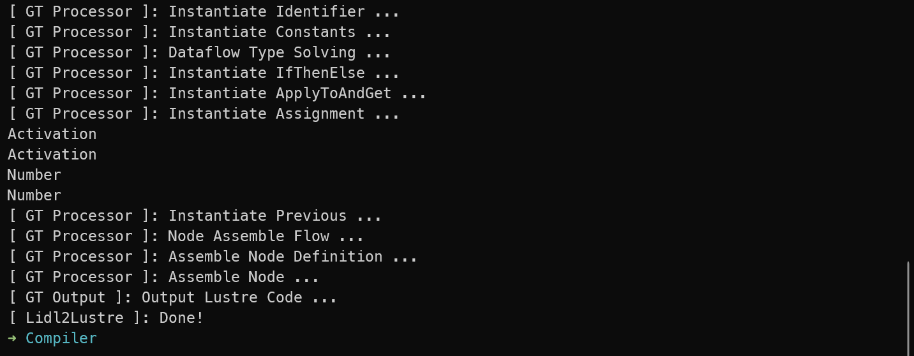

## Compilation results of test cases

After compilation, the compiled result is the Lustre code file (.lus) corresponding to the test case.

